Business Analysis

(Fruit and Vegetable Store)

## **Questions:**

1. How many people work for this company?
2. What is the female to male ratio?
3. Highest paid 5? Highest paid 6-10? Compare?
4. Average salary for men and women?
5. How many registered customers do we have?
6. Top 5 countries with customer count?
7. What is the busiest month? Worst month?
8. Who are our top 5 customers?
9. Best performing countries?
10. Best performing staff?
11. Give bonus to best performing staff? (30% for 1st, 25% for 2nd…)
12. Most wanted food?
13. Least wanted food?
14. Most ordered food by top 5 countries?
15. Get table with the emails and phone numbers?

## **Answers:**

1. How many people work for this company?

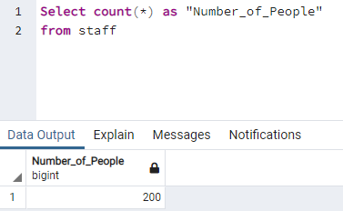

1. What is the female to male ratio?

